Use case diagram:

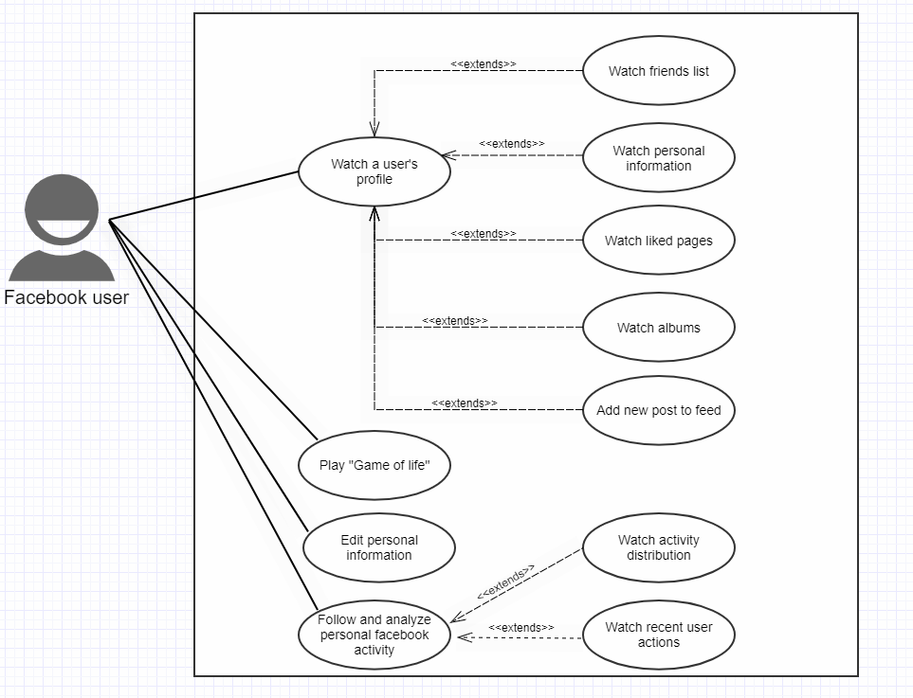

Sequence diagram 1: Play “Game of life”

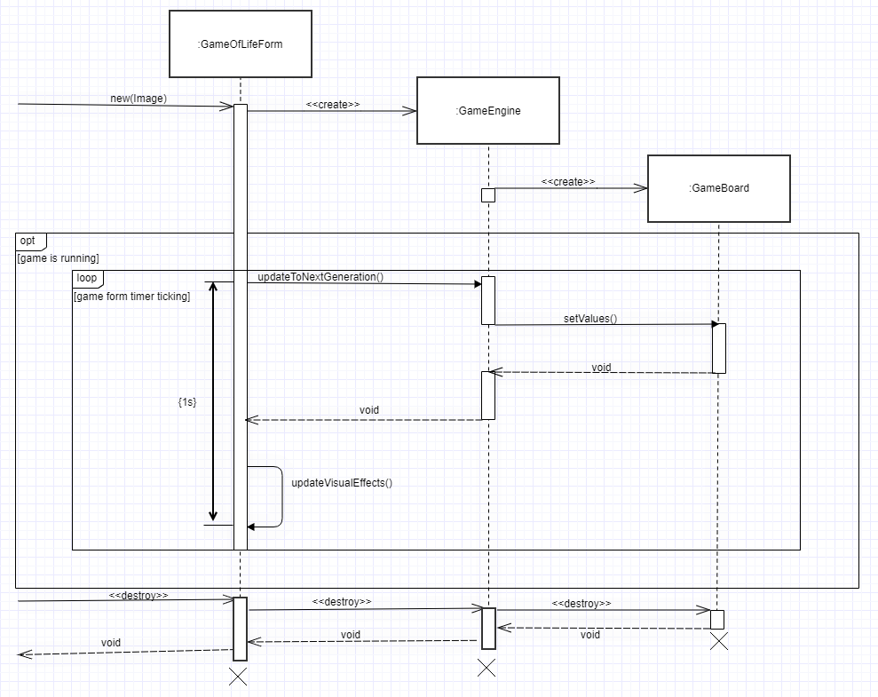

Sequence diagram 2: Follow and analyze personal Facebook activity

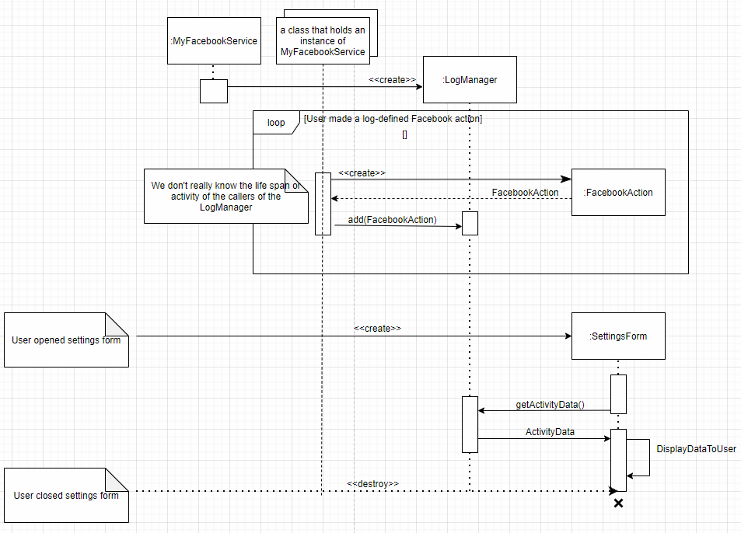

Class Diagram

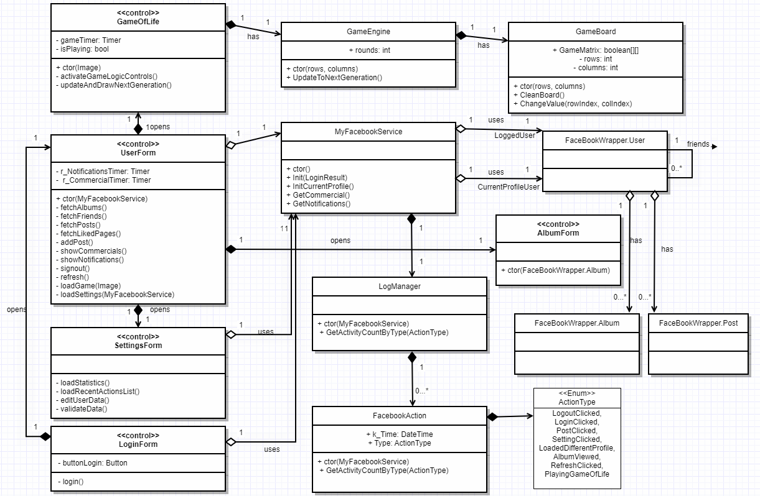

New Features Explained

Game of Life

**John Conway’s Game of Life:**

We will separate the explanation to the feature itself and it’s implementation:

**General:**

The Game of life is not your typical computer game. It is a cellular automation, and was invented by Cambridge mathematician John Conway.  
This game became widely known when it was mentioned in an article published by Scientific American in 1970. It consists of a collection of cells which, based on a few mathematical rules, can live, die or multiply. Depending on the initial conditions, the cells form various patterns throughout the course of the game.

**The Controls**:

Choose a pattern by clicking on the cells, initializing the initial state of the cells to living\dying. The ‘Start’ button advances the game by several generations (each new generation corresponding to one iteration of the rules).

**Classes\Code**

The game consists out of three classes:

1. GameOfLifeForm: the visual container of the game, contains a visual table with a random Facebook friend picture as the background, and buttons as nodes which changes appearance by the logical game engine’s board which we’ll talk about later. The visual table node’s can either be transparent or anti-transparent(black), the more transparent cells – the easier it will be to identify the mystery friend.  
   living cells will be portrayed as transparent while the dead cells are displayed as the other. When the app is open all the cells are dead, and by pressing them you can turn them alive.  
   The form also contains ‘start\stop’, ’reset’ and ‘next’ buttons which apply the logic stated above. The form also contains a timer which acts at this version of the game every second to bring the next generation from the engine by the game’s algorithm and then the form updates it visually.
2. GameEngine: The game engine contains the logical part of the game and the GameBoard(class) logical data.
3. GameBoard: This class contains a boolean matrix which for a true value the node at the GameOfLifeForm will display as transparent and for a false one will be displayed as the other. It also contains some elementary game board actions such as clear board.

Log Manager

This is a feature that tracks the user’s activity in our app.

It provides a documentation of most actions made by the user, sorted by the time the actions were made.

Some of the action types that are monitored by the app are: logging into the app, watching profile of a friend, playing “Game of life” and adding a new post.

In addition, this feature includes a graph-like representation of the actions, which are filtered by the action type.

In order to watch this information, click the “Settings” button in the user’s profile toolbar.

The classes that are associated with this feature are: **SettingsForm** - this is the form that show the data to the user, **MyFacebookService** which holds an in instance of **LogManager** that saves the actions made by the user in a collection, and provides the statistics numbers.